Lead Scoring case study-subjective questions

Q1. Which are the top three variables in your model which contribute most towards the probability of a lead getting converted?

Ans1. Top 3 variables contributing most towards the probability of a lead getting converted are as followings:

* Lead source
* Current occupation
* Last activity

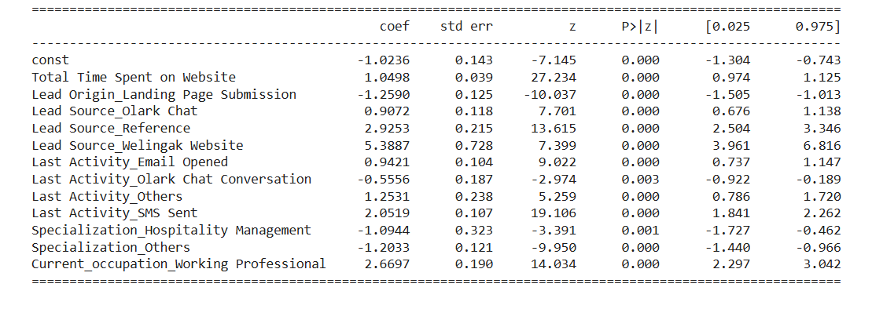

Q2. What are the top 3 categorical/dummy variables in the model which should be focused the most on in order to increase the probability of lead conversion?

Ans 2. After evaluating the last model and as clear from EDA too, following are the main 3 downright factors in the model which ought to be engaged the most to build the likelihood of lead change:

* Lead Source_Welingak Website
* Current_occupation_working Professional are more likely to take the course offered
* Last Activity_SMS Sent

Q3. X Education has a period of 2 months every year during which they hire some interns. The sales team, in particular, has around 10 interns allotted to them. So during this phase, they wish to make the lead conversion more aggressive. So they want almost all of the potential leads (i.e. the customers who have been predicted as 1 by the model) to be converted and hence, want to make phone calls to as much of such people as possible. Suggest a good strategy they should employ at this stage.

Ans3. Particularity can be alluded to as the proportion of all out number of genuine non-changes anticipated to add up to number of real non-transformations. While one increments different declines as well as the other way around which can be accomplished with same model by changing over likelihood cutoff edge esteem. High responsiveness suggests that our model will accurately distinguish practically all leads who are probably going to change over. Since X instruction has more labor for these 2 months and they wish to make the high change rate, we can pick a lower limit an incentive for transformation likelihood which prompts high responsiveness rating changing over leads into sure shot.

So the interns can focus on the following categories of the leads:

* Leads having **‘HIGH LEAD SCORE’** can be focused on more for higher rate of conversion.
* Spend a lot of time on the website.
* Given reason for choosing as for **better prospects**
* **Working professionals**
* **Unemployed category** can be a focus and specialization with **finance management**
* **Referral marketing**

The company may follow high volume low margin strategy which means the conversion rate

Q4. Similarly, at times, the company reaches its target for a quarter before the deadline. During this time, the company wants the sales team to focus on some new work as well. So during this time, the company’s aim is to not make phone calls unless it’s extremely necessary, i.e. they want to minimize the rate of useless phone calls. Suggest a strategy they should employ at this stage.

Ans 4. Following the similar logic from previous answer can help us turn the leads into a higher conversion rate.

* Since, they have reached the target for the quarter they can minimize the rate of useless phone calls.
* Marketing on Google, since the conversion rate is very high.
* Encourage existing conversion leads by gifting referral for every refer.
* Focus on students can be minimized.